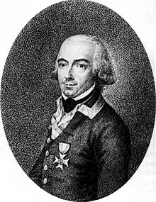
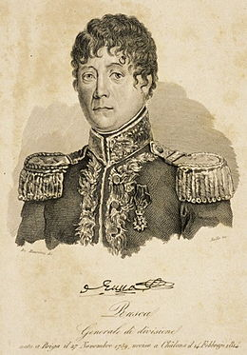

Battle of Klagenfurt
June 6, 1809
FML Johann Gabriel, Marquis du Chasteler de Courcelles vs. GD Jean-Baptiste Dominique Rusca

Start time: 1100 hours. French & Italian allies have first movement. The scenario starts with GD Rusca’s first sortie from Klagenfurt. The Austrian “tripwire” fusilier companies from IR #26 give no alarm. See Austrian “GM Schmidt Surprise rule” below.

End time: 1800 hours (nightfall turn) or if either side retires from the scenario tabletop

Starting MFP level: Franco-Italians have used 11 MFP (51 total) preparing their morning sortie from Klagenfurt. Austrians have spent 21 MFP (of total 72) during the morning hours, conducting their pre-dawn march south of Klagenfurt and positioning their worthless outposts near the Klagenfurt fortress gates.

Special scenario rules: French, Italian & Austrian national characteristics rules in effect. Some are outlined below. See Wargamerabbit.wordpress.com blog site for the current (.pdf) downloads.

Victorious Conscript Morale:
If the Austrian GM Schmidt suffers 40% or greater loss or loses control of Weidensdorf building, the Franco-Italian conscripts can raise their unit CMR +1 upon returning to Klagenfurt and remaining one game turn within the fortress walls. May perform cross-town movement while satisfying the one turn requirement in Klagenfurt (victory parade and prep talk).

French Artillery ammo:
The French and Italian artillery batteries have no reload capability for this scenario. The fortress of Klagenfurt provides all Franco-Italian small arms ammunition requirements. Austrians follow ammunition re-supply rules based upon their Korps Artillery train miniature locations. Note their Korps trains are placed in two locations at scenario start.

GM Schmidt Surprised:
Historically at Klagenfurt GM Schmidt’s command was surprised by the Franco-Italian unexpected assault from Klagenfurt. The tall crops caused visibility problems and GM Schmidt actions that day were not a credit to the Habsburg senior leadership. So, till a Franco-Italian unit, either close order (CO) or open order, appears within 6” of any GM Schmidt’s units, they may not move from their starting position (C5 and D5) unless another Austrian command or group is attacked (ie assaulted, charged, fired upon etc) anywhere on the scenario tabletop. Stationary CO formation changes (including deployment of skirmishers) are permitted but they cannot retire or advance from their position unless movement restriction lifted.

Battalion Masse:
  - Austrian regular infantry (Line or Grenadiers) units had a special anti-cavalry formation called “battalion Masse”. When a regular infantry battalion is formed into a dense column with the miniatures arranged at least 3 ranks deep then the battalion is formed for a battalion masse formation. When faced by a cavalry charge morale check, the battalion has a +2 CMR adjustment morale modifier to pass the morale check. No modifier is given for infantry shock combat. The front face of the battalion is assumed to be a square formation vs. charging cavalry shock combat. When using musket fire, use the normal 3 rank firing line found on the small arms firing charts. If the battalion is in morale disorder, all benefits for battalion masse are lost. The battalion masse formation can be used against European and Ottoman Turk armies.

Militia Rule (M): All Austrian 1809 Landwehr and Insurrection battalions follow the Militia rule below restrictions.

Units rated as militia (code M) have several rules unlike normal regular units. Militia (code M) units are locally raised levy units and have very limited training or active service, especially in defense against charging cavalry.

- No actual square formations allowed. May form “all rounded” firing formation but still have -2 CMR adjustment for shock combat with charging cavalry unless Ottoman / Islamic state unit (see d. below).
- “All rounded” formation still test for charging cavalry using basic CMR rating (adjusted for losses etc) only instead of normal -5, -3 or -1 receiving CMR adjustment for foot units not in square formation. Note the difference that square formations don’t morale check for charging cavalry but “all rounded formations” do morale check.
- “All rounded” formation don’t receive the +5 CMR square defensive formation adjustment in shock combat and suffer the -2 CMR shock combat for not being in square vs. charging cavalry.
- Ottoman / Islamic states units don’t suffer the -2 CMR shock combat adjustment for charging cavalry.
- “All rounded” formation firepower as a square formation.
- “All rounded” formation cannot move unlike a square formation.
- European or USA militia rated units having CMR 4 or less use Class C movement rates. Ottoman or Islamic states Class A movement rates.

Third (3rd) Rank skirmishers:
Only campaign seasoned Austrian regular units or units with 7 CMR or greater receive the third (3rd) rank skirmisher deployment ability. The Austrian regulars in FML Chasteler’s Korps have this ability for this scenario.

Using this rule, veteran or campaign seasoned regular line battalions can deploy their “third rank” as semi-open order skirmishers before their parent unit. Third (3rd) rank skirmishing follow all open order formation rules. Availability and use rules are:

- If the infantry battalion has a permanent “Voltigeur or similar light company” within the battalion organization structure then this rule cannot be used to deploy the center company miniatures as skirmishers.
- Prussian styled volunteer Freiwilligen jagers (FWJ) are not considered light company skirmishers (per a. above) as they are not part of the Prussian battalion or cavalry regiment organization on a “permanent basis”. Freiwilligen jagers do count towards the determination of how many miniatures can be deployed.
- No green “conscript” rated or units with a CMR 4 or less can deploy third (3rd) rank skirmishers.
- Up to one third (1/3 RD) of the battalion’s miniatures can be deployed as semi-open order skirmishers within 5” of the parent battalion. If the parent battalion retires away, the skirmishers must be moved to retain the maximum 5” deployment radius.

Bridge Capacity:
All scenario map bridges can cross 18 infantry, 9 cavalry or 3 artillery batteries / train per movement phase. Miniatures remaining over the water count during each game phase for capacity. Routing units across the bridge may cause over capacity issues. See main rules for details on bridge capacity limits.

Fortress Gate Capacity:
All scenario fortress gates in Klagenfurt can transit 18 infantry, 9 cavalry or 3 artillery batteries / train per movement phase. Exceeding these limits causes automatic morale disorder for all units transiting the gateway.

Weather: Clear and sunny late spring day, use Chart #4.

Line of communications (LOC): French LOC goes to into Klagenfurt (Marienkirche building) for this scenario and is the direction Franco-Italian units will retire or rout towards normally. Normally a Divisional level or lower command level doesn’t have a LOC trail back to its senior commander. Typically LOC traces from the senior level commanders HQ base upwards in command chain to Army level, then to the King or Nation level commander. Austrian LOC from Korps HQ (starts scenario at H4) traces back to A3 using the southern secondary road, Once the Austrian Korps HQ base is deployed and functioning east of the Glan River, the Austrian LOC changes to H3 exit for remainder of the scenario.

Terrain notes: Terrain per the standard terrain charts with the following special notes. Three different waterways are on scenario battlefield. Lend Kanal is similar to narrow river and un-crossable except at the bridges or inside Klagenfurt. Klagenfurt wall moat is similar and also un-crossable except at the fortress gateway bridges. The Stadt Kanal drainage ditch is a terrain disorder stream, and cost 2” to cross for infantry or cavalry. No artillery or train miniatures can cross Stadt Kanal except at bridges. Kalvarienberg heights are infantry only terrain disordering, with 4” CO movement cost, unless the infantry unit remains stationary for a movement phase (no formation changes or physical miniature movement). Unit skirmishers can freely deploy without causing terrain disorder. No artillery or cavalry on the Kalvarienberg. All buildings are Class II structures. Klagenfurt old fortress walls are un-crossable and proof against all field artillery damage but units positioned on the fortress wall can suffer loss (1/10th target). The fortress gateways are Class III fortress gate defense if assaulted. The fortress gates cannot be locked and left unattended, as the local citizens of Klagenfurt will unlock for any Austrian unit seeking entrance. All open ground in Klagenfurt is assumed to be roadway for movement purposes.

Battle Map picture (w/o counters):
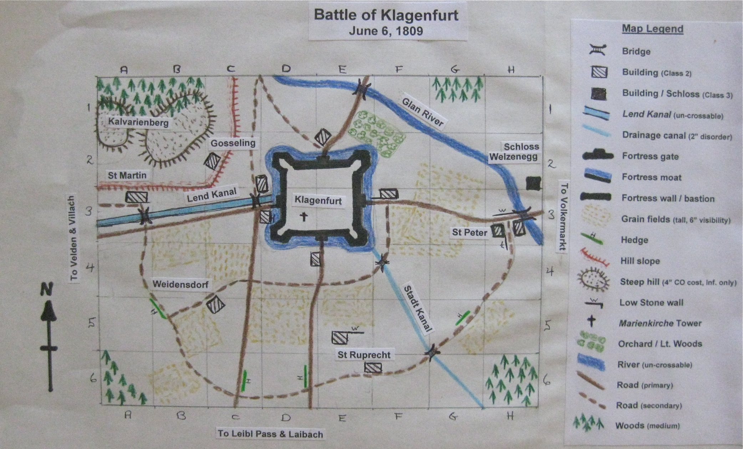
Map Scale: 1-foot tabletop grid squares at 50 yards to inch. North direction is given by arrow. Map legend at right to identify terrain features. See Terrain notes for effect on movement & shock combat.

Battle map with command counters:
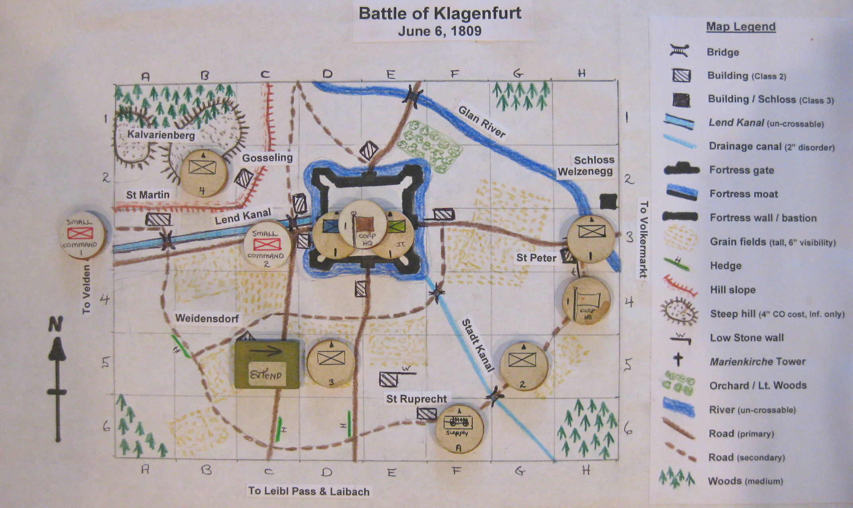

Starting positions and Orders (LOC): All French are acting under “Advance position” senior order with GD Rusca’s Divisional HQ acting like a senior Corps level headquarters for this scenario. Austrians are under Korps senior command level (FML Chasteler) and use the “Advance position” order selection. Both sides have all their starting on tabletop commands either in strategic or battle mode with the initial order restrictions detailed below. All off map reinforcement commands are in strategic March order. All French, their Italian allies, and Austrians units set up in the rear half of each map square per normal miniature tabletop deployment rules. Definition of command orders covered at Wargamerabbit.wordpress.com.

French and Italian allies:
Rusca Division HQ (Rusca) D3 with HQ unit attachments
1st Italian Brigade (Bertoletti) Either D3 or E3 or E4 with Attack order
2nd French Brigade (Julhien) Either D3 or E3 or E4 with Attack order

Austrian:
Austrian Korps HQ (Chasteler) * H4 with only one HQ ammo train attached *
Advance Guard (Lachovsky) H3 with March orders
Main body (Fenner & Marcal) G5 with March orders
Volkmann Detachment (Volkmann) B2 with March orders
Schmidt Detachment (Schmidt) ** C5 and D5 with Engage orders **

- HQ detached group (2nd Banal Grenz) at off map A3 with one ammo and baggage train miniature and under Austrian HQ command structure. The rest of Korps baggage trains (3) are all in F6 traveling along the secondary roadway east.
- The Luis Schutzen Freikorp detachment (Schmidt) is placed in open ground, open skirmisher formation, on roadway in C3 under Schmidt’s detachment Engage order.

Off map reinforcements: Franco-Italians have no reinforcements for scenario.

The Austrian small rear baggage and train group with 2nd Banal Grenz guard are off map at A3. They may enter and attempt to transit the southern road route from 1200 hours onwards. If GM Schmidt’s command reaches 60% or greater loss level they will march away and flee the scenario tabletop along with his shattered command unless in C6 or further east.

Order of battle:
French:
Rusca’s Division HQ (Rusca)
Sapper detachment 1x2 CMR 8
Baggage train (1) CMR 4 remains in Klagenfurt during scenario

1st Italian Brigade (Bertoletti)
3rd Btn / 1st Italian Legere 1x7 CMR 6
3rd Btn / 2nd Italian Legere 1x8 CMR 6
3rd Btn / 4th Italian Line 1x7 CMR 5
Istrian Btn. 1x7 CMR 5
1st Italian Chasseurs a’ cheval 1x2 CMR 7
6lb Italian foot battery (6) CMR 7

2nd French Brigade (Julhien)
4th Btn / 67 Line 1x10 CMR 5
4th Btn / 93rd Line 1x8 CMR 5
2nd Italian Chasseurs a’ cheval 1x2 CMR 7
6lb foot battery (6) CMR 7

Austrian:
Tyrol Korps HQ (Chasteler)
2nd Banal Grenz baggage detachment 1x3 CMR 6
Korps ammo train (2) CMR 5 in two locations
Korps military train and baggage (4) CMR 4 in two locations

Advance Guard (Lachovsky)
2nd Banal Grenz 1x5 CMR 6
Hohenzollern Chevaulegers #2 sgn. 1x2 CMR 7
9th Jagers 1x2 CMR 7
Converged Landwehr btn. 1x4 CMR 4

Main Body (Fenner & Marcel)
IR #26 Hohenlohe-Bartenstein 2x6 CMR 6
Hohenzollern Chevaulegers #2 1x4 CMR 7
1st Villach Landwehr 1x5 CMR 4
2nd Bruck Landwehr 1x5 CMR 4
1st, 2nd, 3rd, Klagenfurt Landwehr 3x5 CMR 4
6lb converged Brigade battery (6) CMR 7

Volkmann Detachment (Volkmann)
IR #53 Johann Jellacic [hun] 3x7 CMR 6
Hohenzollern Chevaulegers #2 sqn. 1x2 CMR 7

Schmidt Detachment (Schmidt)
IR #52 Franz Karl 1x7 CMR 6
2nd Banal Grenz 1x7 CMR 6
Lais Schutzen Freicorps 1x2 CMR 5

WR used a rough 1:90 miniature scale for the orders of battle. (2x6) = 2 battalions of 6 infantry miniatures each. Cavalry are regiments or squadron detachments. (6) for artillery equals 6 cannon in battery. (2) train means two train miniatures.

Victory conditions:
French, Italian or Austrian units leaving the tabletop via any table edge, except the eastern one, are considered lost before nightfall. The eastern escape route applies for both sides, Austrians trying to escape to join the Army of Inner Austria and the Franco-Italians seeking to rejoin with GD Marmont.

1). If both Franco-Italian brigades suffer 40% or greater losses, increase the Austrian victory level by one.

2). If somehow the entire Austrian military train, including the two train miniatures escorted by the 2nd Banal Grenz, exits the tabletop at H3, increase the Austrian victory level by one.

3). If the French destroy or prevent three (out of six total) military or baggage trains from exiting the tabletop at H3, then increase the French victory by one level.

French Major Victory: Clear the scenario battlefield completely of all Austrian command west of the Glan River and inflict two Austrian commands with 40%+ loss percentage.

French Minor Victory: Inflict two Austrian commands with 40%+ loss percentage but one or more Austrian commands remains west of the Glan River at nightfall, not on the Kalvarienberg. Kalvarienberg heights are defined as the eastern larger hill overlooking Klagenfurt for victory conditions.

Draw: Austrian control or be contesting the 2nd level Kalvarienberg heights overlooking Klagenfurt at nightfall. Kalvarienberg heights are defined as the eastern larger hill (nearest Klagenfurt) for victory conditions. [Historical result]

Austrian Minor Victory: Contain the Franco-Italian Rusca Division within 1’ of Klagenfurt city walls and Austrians commands can exit without interference, the tabletop at H3.

Austrian Major Victory: Total Franco-Italian disaster if the Austrians taking control of any Klagenfurt fortress gate, and Austrians commands can exit without interference, the tabletop at H3.

Rules of Play: Wargamerabbit.wordpress.com has a rules section providing files; charts, table and game play example YouTube videos.

Special event cards: None for this scenario.

